Long Term Goals: Reception
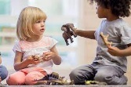    PSED  To become a fantastic friend  who can be kind, caring and helpful, show empathy and respect to others, work and play co-operatively whilst considering others’ ideas and feelings | 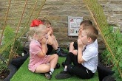  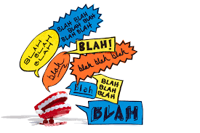  C&L  To become a confident communicator who can listen carefully in different situations, hold a conversation with friends and adults, ask relevant questions and use new vocabulary to explain ideas and feelings | 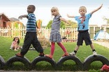  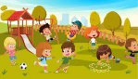  PD/ PE  To become an amazing athlete  who can show strength, balance and co-ordination when playing, move confidently and safely in a variety of different ways, use a range of equipment | 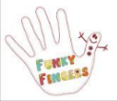  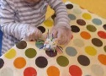  Finger Skills  To become a talented tool user  who can hold a pencil effectively, use a range of tools (for example scissors, cutlery, paintbrushes, tweezers, hammer, screwdrivers) safely and with confidence
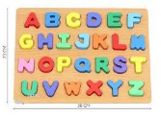  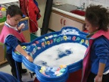  Phonics  To become a Phonics Superstar who can segment and blend words including digraphs and trigraphs for both their reading and writing and can read some common exception words | 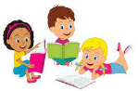  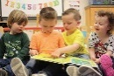  Reading  To become a brilliant bookworm who can show a love for reading, use new vocabulary to talk about what they have read or has been read to them, read words and simple sentences (using single sounds and digraphs they have learnt) | 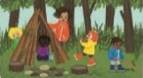  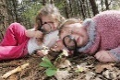  Writing  To become a wow writer who can write letters that are formed correctly, write words and simple sentences (using single sounds and digraphs they have learnt) that can be read by others |   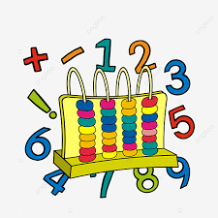  Maths  To become a master of maths who can show a deep understanding of numbers to 10, recognise patterns within the number system, subitise, compare quantities and recall number bonds to 5
  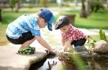  UW  To become an exceptional explorer who can show curiosity about the world around them, understand how to read and draw a simple map, understand some differences between times and places |     Citizenship  To become a compassionate citizen who can help to look after their community and care for the environment, know some reasons why Bideford is special, have an awareness of other people’s cultures and beliefs | 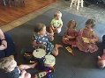  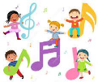  Music and Dance  To become a proud performer who can perform a song, poem or dance to an audience, retell stories with expression and confidence, play a range of percussion instruments correctly and with good rhythm | 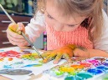  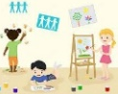  Art  To become a dynamic designer who can choose and safely use the resources they need to make their creations, talk about what they have made and how they have made it

