Long Term Goals: Nursery
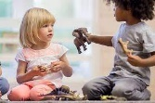    PSED  To become a ‘Shining Star’ who happily greets and interacts with others, sharing thoughts and resources patiently; valuing self and others and willing to persist and not be daunted by failure | 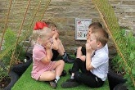  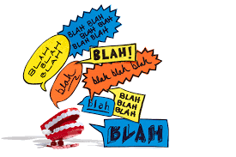  C&L  To become a ‘Happy Chatter’ in everyday play and focussed sessions, showing the ability to follow instructions, concentrate, think through and extend ideas and real and imaginary thoughts with others | 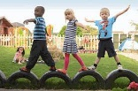  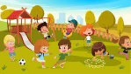  PD Outside  To become a confident ‘Risk Taker’ and develop body strength when climbing up, across and down using various equipment. Whizzing around the track on a trike, bike or scooter and digging and constructing various items | 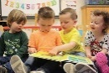  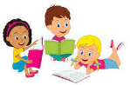  Reading  To become a ‘Book worm’ enthusiast and readily access books for pleasure, turning pages individually, describing characters, scenes and outcomes in illustrations and recognising some symbols and letters of personal interest in their environment including digital material
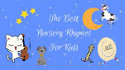  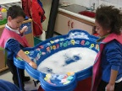  Phonics  To become a Phase 1 ‘Lightening Listener’ with radar hearing, discerning, remembering, sequencing and creating dynamic sounds in everyday play, with awesome rhyme awareness and beginning to orally segment and blend | 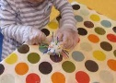  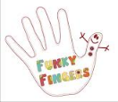  Pre-writing Skills  To become a ‘Funky Finger’ enthusiast who builds up hand and whole-body strength through adventurous play, to be able to enjoy mark making readily and confidently with a good grip |   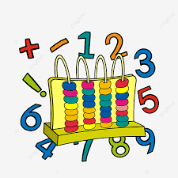  Maths  To be a ‘maths wizard’ and use the ‘magic’ of embedded mathematical knowledge and the language naturally in everyday play. Subitising, counting and representing marks to at least 5 and matching, measuring and comparing all sorts | 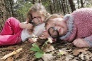  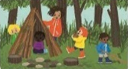  Forest School  To become ‘Eco-Warriors’ who explores the outside world and all the creatures within it, ensuring they love and take care of the environment around them
  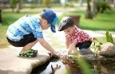  UW  To become an ‘Intrepid Explorer’ who investigates challenges with an inquiring mind and uses breadth of vocabulary and investigative tools to observe, remember, explain and predict | 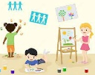    Art  To become a ‘Creative Curator’ who develops ideas using embedded skills, techniques and knowledge of experiences and artists to represent and complete their ideas | 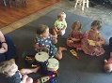    Music and Dance  To become a little ‘Music Mover’ who can discern a few instruments, attempt to play them loudly, softly, fast and slowly whilst developing and ear for rhythm |   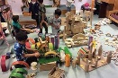  Construction  To build a ‘Crafty Construction’ model that has multilayers of purposefully positioned pieces and spaces between

